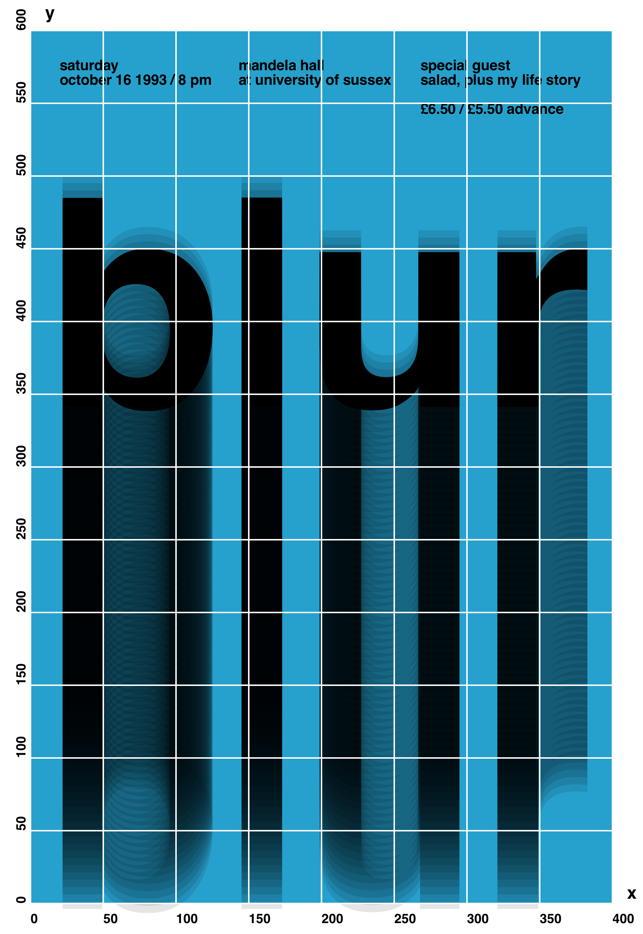
Planning Sheet Show how you will use sequence (order of statements), conditionals (if statements), and iteration (loops) to reproduce this image.

