Intro to Computer Studies – Final Exam – Matching Visual Output
Curriculum Expectations: B1, B2, B3

The purpose of this assessment is to determine your ability to:
- identify situations in which decision and repetition structures are required
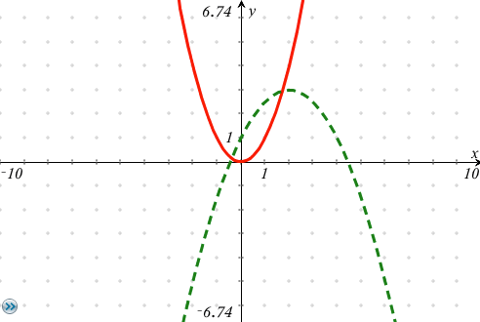
- use operators and expressions effectively
- apply sequence of statements
- apply basic code maintenance techniques

… to author a computer program that produces visual output that is identical to a given image.

Each evaluation category below counts for 25% of your grade on the final exam.

 | CRITERIA | LEVEL 1  Novice | LEVEL 2  Apprentice | LEVEL 3  Practitioner | LEVEL 4  Expert | Achievement level earned  and comments, if needed.
K  N  O  W  L  E  D  G  E | - Correct sequence of statements used to generate an image that matches the given image.  - Demonstrated ability to verify and validate that generated image matches target image. | Few elements of the target image have been created by your code. | Obvious differences between the image your code generated and the target image, but some elements of the target image have been made. | You have hit all of the broad strokes of the target image but there are some differences that could have been corrected with greater understanding of core programming concepts. | There is absolutely no discernible difference between the image generated by your program and the provided image.
THINKING | - Uses repetition structures effectively to produce an efficient solution.  - Shows ability to effectively use conditional statements with boolean operators. | None or little use of repetition structures where appropriate.  Little or no effective use of conditional statements. | Some use of repetition structures but clearly missed opportunities to write more efficient code.  Some effective use of conditional statements where appropriate. | Generally found necessary places to use repetition structures to create an effective solution.  Clear ability to use conditional statements where necessary but could be more efficient. | Found all possible cases where repetition structures could be used to generate an effective solution.  Obvious ability to identify and use most efficient conditional statements possible.
C  O  M  M  U  N  I  C  A  T  I  O  N | - Appropriate use of whitespace to separate logical sections of code.  - Good use of comments to describe intent without over-documentation of code that inhibits readability.  - Meaningful variable names used with camelCased capitalization. | Little to no use of whitespace or indentation to make code readable.  Little to no use of comments to make solution readable.  Little to no use of meaningful variable names. | Some use of whitespace or indentation to make code readable.  Some use of comments to make solution readable.  Some use of meaningful variable names. | Generally adequate use of indentation and whitespace to make code readable.  Comments are provided in most but not all cases to make program understandable to others.  Most variable name selections improve the readability of the program. | Excellent use of whitespace and indentation to make code readable.  Clear, concise comments provided at every point necessary to create a human-readable solution.  Excellent use of variable and function names to improve readability of program.
APPLICATION | - Existing classes or functions used efficiently to generate target image.  - Expressions were used to minimize the amount of hard-coded values.  - Demonstrates the ability to independently identify and correct syntax, logic, and run-time errors. | Minimal or no appropriate use of existing subprograms.  Minimal or no use of expressions to create an efficient solution. | Some use of existing subprograms to create an efficient solution.  Some use of expressions to create an efficient solution. | Generally good use of existing subprograms to create an efficient solution.  Expressions generally used to generate the target image with minimal lines of code. | Obvious and creative use of existing subprograms to create an efficient solution.  Expressions and operators used to generate an accurate solution with minimal lines of code.

Overall comments and feedback

